Long Distance Tracking and Monitoring with LoRa
Stuart Robinson

Testing and Comparing

Many things can affect the performance of a radio link, the location, how far apart the transmitter and receiver are, the way the modules are constructed, battery levels, type of antennas and whether the modules have been damaged or not. At the low power levels used by the LoRa modules, typically 10mW or less, many constructors will not have test equipment capable of measuring such low powers. A similar problem exists for tuning antennas, SWR meters capable of operating at these low powers are not common.

The LoRa modules are capable of measuring the level of signals or noise seen at their antenna input and of carrying out measurements of signal level and noise during packet reception. These measurements may not be to laboratory standard accuracy wise, but they do allow comparative tests to be made. Very often a comparative test is perfectly adequate.

If everything in the link between transmitter output and antenna is always a 50ohm impedance then you can use conventional equipment, such as SWR meters to design and then tune antennas and be reasonably certain that you have the best antenna for the job. This is very likely true for sophisticated radio equipment that will be built and aligned for 50ohm output.

Low cost radio modules, such as the LoRa Hope RFM9x and Dorji DRF1278F are made using very low cost components with no tuning or other adjustment in manufacture. Its therefore quite possible that the RF output impedance is not 50ohm at all, so tuning an antenna with precision 50ohm test equipment or computer modelling cannot tune the antenna for maximum radiated power.

Fortunately it is not difficult to use very simple methods for tuning antennas for maximum radiated signal with piratical tests that mimic real life operation as opposed to laboratory or based tests or computer simulations.

A benchmark test that can be used to check the performance of a pair of 433Mhz LoRa modules or their antennas would also be useful. If its known what the RSSI (signal strength) indication is for a LoRa receiver under a controlled set of test conditions, its possible for anyone to establish if a transmitter and receiver pair is working as expected.

A LoRa receiver can easily be used as a signal strength meter if a LoRa transmitter is used to send a series of test data packets. As long as the receiver is at a consistent distance and position in relation to the transmitter, then differences in effectiveness of antennas on the transmitter and receiver will be seen as differences in signal level at the receiver. For instance, once the test environment is set-up it becomes quite easy and quick to test a range of different receiver antennas for relative performance. Most often we do not want to or need to know the precise relative gain performance, we just want to know which is the best antenna, A, B or C ?

Note that the relative differences in received signal strength should equate to relative differences in transmitter or receiver antenna performance. If with a particular antenna the received signal strength increases by 3dB, then that antenna has a relative gain of 3dB, which equates to about 40% extra range performance.

To carry out our standard benchmark test, we need a transmitter and receiver modules loaded with the test software, see appendix for the details. For the purpose of this test the transmitter has a simple wire antenna, as it would if it was a lost model locator. The receiver has a simple ¼ wave whip made from piano wire. This is an easy build antenna, just solder the length of wire into the pin on a SMA plug intended for assembly onto coax. Insulate the wire from the metal of the plug, the centre of a piece of coax is good for this. I have assumed the receiver has been built with a SMA coax socket on it. Put a bit of cork on the end of the antenna wire.

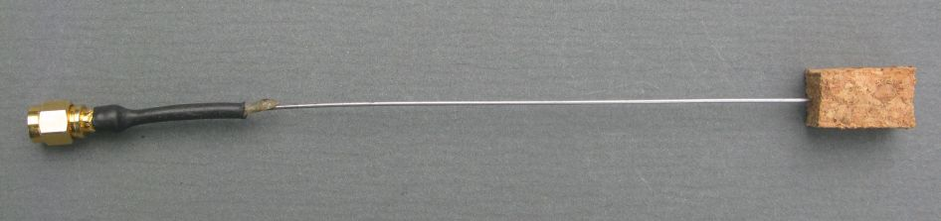
¼ Wave Wire Antenna

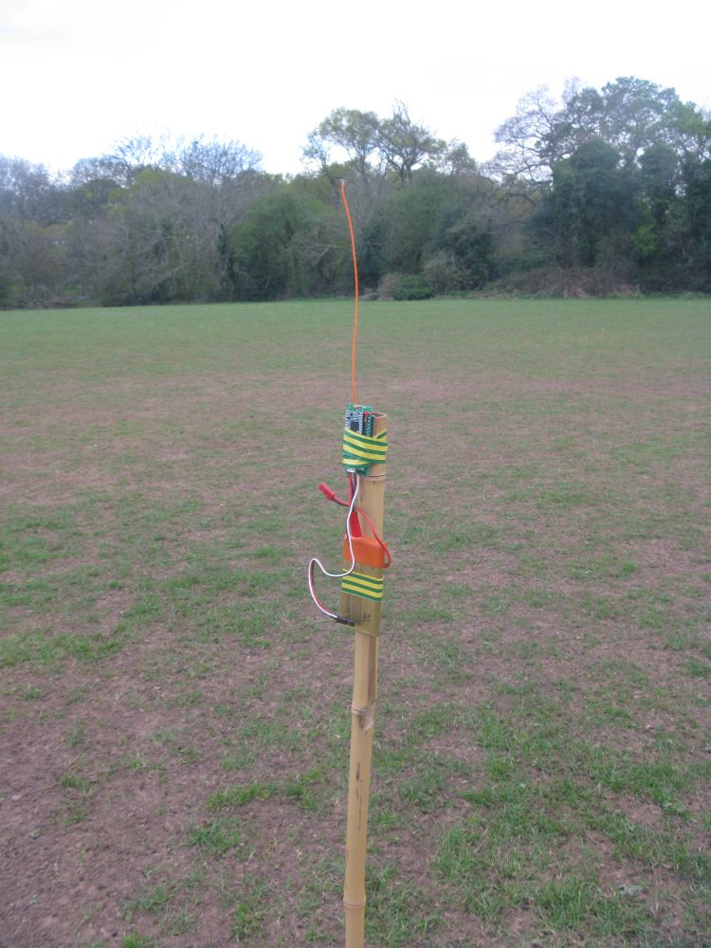
All you need now is a large grass field, around 150M across and a non-metal cane or pole around 1.5M high. Load the transmitter with the test software (explained later in the section Test Software – Descending Power Tests) and secure it to the pole with a bit of tape, see picture. In this case the transmitter test software has a start power of 10dBm and a finish power of 10dBm, meaning that it will only transmit a 10dBm packet. The LoRa modem settings are bandwidth 62.5khz, Spread Factor 12, Code rate 4:5. You can use either the short test packet or there are l
onger packet which includes GPS sample co-ordinates.

Transmitter on Pole

Make sure the transmitter antenna is vertical and straight. You can use a laptop with a serial monitor to view test results but it is a lot easier to use a receiver that has been built with a serial LCD connected as described in a document to be published shortly.

Walk 50M away from the transmitter and stand sideways to the transmitter so that your body does not act as a reflector and affect the readings.

The receiver will display on monitor (and LCD if you have one) the RSSI, Noise and SNR of the received packets.

Results at 50M for 10dBm (10mW) Transmitter Output Power

I tested two different transmitters, these were the results;

PIH LML 1 TX – Loose 1/4wave wire antenna RSSI -55dBm, Noise -97dBm, SNR +9dB
PIH LML 2 TX – Loose 1/4wave wire antenna RSSI -56dBm, Noise -94dBm, SNR +9dB

I had similar results with a transmitter fitted with a SMA socket and stiff ¼ wave wire antenna.
The Noise level is a background reading taken when there is no packet being received, it does initially display a very low reading, -137dB or so, but it settles down after a few loops.

For those that may have an RFExplorer, the RF carrier that is the audio tones sent by the test software was measured as -60dBm at 50M.

I confirmed the 10mW output power with the RFExplorer. With an attenuator connected to make sure you don’t blast the input of such a sensitive instrument, the RFExplorer can be used to measure the power output of the LoRa devices.

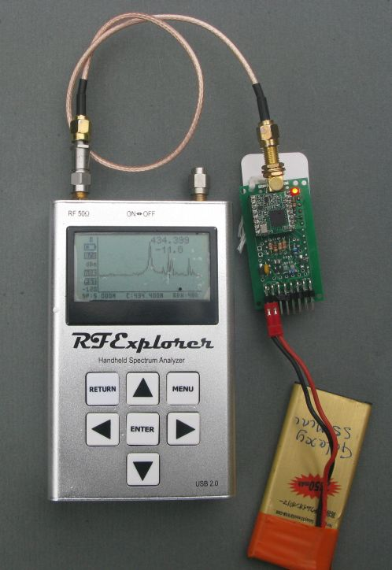

RFExplorer used to measure transmit
Power

So there we have it. It should be an easy test for anyone to duplicate, and is a simple way of detecting failed modules. The LoRa modules are prone to damage if operated without an antenna, with these modules the received signal RSSI will be much lower than the -56dBm shown above, maybe in the region of -80dBm or so.

Weakest Received Signals
In a large open field you would need to walk a very long way from the transmitter before signals from the transmitter are so weak that reception is lost. However if you put the transmitter on the ground in an urban area or in a forest, there will be heavy attenuation of the signals and reception will likely fail at between 300M and 1000M from the transmitter. This is not meant to be a test as to what range you will get, that can vary greatly depending on the terrain, all we are doing is attenuating the signals so they are very weak. Walk away from the transmitter till the signals stop being received. The weakest signals received in my tests were;

RSSI -97dBm, Noise –99dBm, SNR –16dB
Expect some variation for your own set-ups. If there is a lot of RF noise around, the RSSI figure would likely increase as stronger signals are needed to overcome the noise level.
Test Software – Descending Power Tests
I have written some link test software for the LoRa SPI modules based on the Semtech SX127x RF IC. Typical modules used are the Dorji DRF127X and Hope RFM9x series. The software uses my own libraries for LoRa and should run on the majority of Arduino supported hardware.

The software is located here;

https://github.com/LoRaTracker/Link-Tester2

There is a transmitter and a receiver program. The LoRa devices mentioned above are 3.3V devices so make sure your Arduino is compatible, an Arduino Pro Mini 3.3V is ideal.
The link test programs use the following pin name definitions from the ‘Pin_Definitions.h” file to drive the LoRa device, you need to connect these up according to your hardware. The example below is for an Arduino Pro Mini;

#define lora_NSS 10 //Chip select for the LoRa device NSS pin
#define lora_NReset 9 //Reset for the LoRa device Reset pin
#define lora_TonePin 6 //for radio tone generation, LoRa device DIO2 pin
#define lora_DIO0 2 //LoRa device DIO0 pin
#define LED1 8 //pin number for LED if you want flashes

And of course you will need to connect up the 3 hardware SPI pins to the LoRa device;

MOSI 11
MISO 12
SCK 13

Locations of MISO, MOSI and SCK do vary according to the Arduino hardware used.
The Link Tester programs will send a series of test packets at a given set of LoRa parameter (Frequency, Bandwidth, Spreading Factor and Coding Rate) according to the settings in the ‘Test.Settings.h’ file.

The ‘Test.Settings.h’ file also contains the LoRa parameters to be used for sending the test packets, these are in the simple case of only using 1 mode (2 mode testing is described later);

const unsigned long Frequency1 = 434400000; //mode1 frequency in hertz
#define test1_Bandwidth BW62500 //LoRa bandwidth
#define test1_SpreadingFactor SF8 //LoRa spreading factor
#define test1_CodeRate CR45 //LoRa coding rate

In this case there for the test packets will be sent at bandwidth BW62500, Spreading Factor 8 and Code Rate 4:5, the full set of definitions you can use is;

//Constant names for bandwidth settings
const byte BW7800 = 0; //7.8khz
const byte BW10400 = 16; //10.4khz
const byte BW15600 = 32; //15.6khz
const byte BW20800 = 48; //20.8khz
const byte BW31200 = 64; //31.2khz
const byte BW41700 = 80; //41.7khz
const byte BW62500 = 96; //62.5khz
const byte BW125000 = 112; //125khz
const byte BW250000 = 128; //250khz
const byte BW500000 = 144; //500khz

//Constant names for Spreading Factors
const byte SF6 = 6;
const byte SF7 = 7;
const byte SF8 = 8;
const byte SF9 = 9;
const byte SF10 = 10;
const byte SF11 = 11;
const byte SF12 = 12;

//Constant names for coding rate settings
const byte CR45 = 2; //4:5
const byte CR46 = 4; //4:6
const byte CR47 = 6; //4:7
const byte CR48 = 8; //4:8

These settings can be translated into a data rate or on air time using the ‘Semtech LoRa Calculator’ which you can download from here;

http://www.semtech.com/apps/filedown/down.php?file=SX1272LoRaCalculatorSetup1%271.zip

In general the longer a packet takes to transmit the further it will go in distance terms.

The basic principle of the link test programs is that you decide on the LoRa settings and then define a start power and and end power. The transmitter program will then send out a series of test packets at starting at ‘start_power’ and ending at ‘end_power’. If you set these to 10 and 2 respectively, the link test transmitter will send out packets starting at 10dBm (10mW) reducing in 1dBm steps until it reaches 2dBm (1.6mW). The test packets are formatted to contain the text value of the power used to send a packet, so the receiver is able to identify the power used to send what it is receiving.

The test loop will run in this example from 10dBm to 2dBm, pause a short while and start the test loop again. If you have a UHF FM hand-held receiver tuned to the test frequency you will hear a tone at the start of the test loop (i.e. at the 10dBm point).

You then need to program the receiver up with the same frequency and LoRa settings. Again the hardware can be simple and is set-up in the same way as the transmitter. The receiver will need to be connected to a serial console on a laptop or similar in order to see what the receiver is detecting, you can use the serial monitor in the Arduino IDE.

If you start up the transmitter and connect the receiver you will see the receiver reporting the receipt of packets like this on the terminal monitor;

RX SNR,4dB RSSI,-23dB RXType,T Destination,* Source,1 Length,6 (6dBm)
RX SNR,4dB RSSI,-22dB RXType,T Destination,* Source,1 Length,6 (5dBm)
RX SNR,4dB RSSI,-22dB RXType,T Destination,* Source,1 Length,6 (4dBm)
The serial monitor reports the signal to noise ratio (SNR) received packet, this could be as low as -20dB in some LoRa modes, the received signal strength indication (RSSI) at the limit of reception this could be in the -100dB region, the type of packet (T for test) the destination of the packet (* for a broadcast) and the source of the packet (1 for node 1), the length of the packet in bytes (6) and the power that was used to send it (6dBm for instance).

So what is the value of all this?

At the end of a test loop (when all packets from 10dBm to 2dBm have been sent) the transmitter sends an information packet for the receiver which is an indication to the receiver to print the running totals for packets received, it looks something like this on the terminal;

Mode1 17,0 16,0 15,0 14,0 13,0 12,0 11,0 10,12 9,12 8,10 7,3 6,0 5,0 4,0 3,0 2,0

What this tells us is that packet reception was going well at 10dBm, 9dBm and 8dBm but by the time we got down to 7dBm the packets were so weak that very few were received.

Now lets assume that the above set of results was for antenna A and that we switch the transmitter (or receiver) over to a different antenna B, being very careful to keep it in the same position, orientation and height as we used for antenna A. We run the test again and the results are;

Mode1 17,0 16,0 15,0 14,0 13,0 12,0 11,0 10,12 9,12 8,12 7,12 6,12 5,9 4,2 3,0 2,0

In the second test with antenna B, packet reception was now failing most of the time at 4dBm (so 3dB lowere than before), so we can conclude that antenna B is around 3dB better (has more gain) then antenna A.

You can use the same methodology for testing reception at different locations or distances, although for distance testing alone, a simple modification to the ‘Test_Settings.h’ file will make the link test programs easy to use for that purpose. This will be described at a later date.

If when you run the test you receive all packets down to 2dBm, either move the transmitter further away or reduce the transmit power in some way. The easiest way to reduce power transmitted is to use attenuators on a transmitter that has a SMA socket fitted. These attenuators for SMA connectors are readily available, try eBay. Good values of attenuator to have handy are 10dB and 20dB. As an alternative you can cut the transmitted power significantly by fitting a 50ohm SMA terminator (dummy load) on the transmitter output. This can reduce range to a few 10s of metres, especially if the transmitter in put in a metal tin, which can be a useful testing strategy if you don’t have a lot of space.
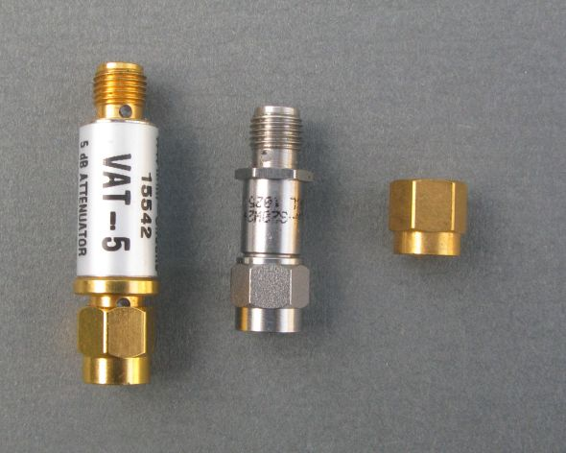

Two SMA attenuators
and a terminator

You can even use the test reciver software without a PC as a terminal, which can be handy if your on a remote mountain top. With a UHF hand-held listen for the two start tones on a UHF hand-held and count the LED flashes on the receiver indicating a packet received. If the transmitter starts at 10dBm and you count 5 flashes on the receiver, your picking up down to the 6dBm packet.

Stuart Robinson
GW7HPW
17th October 2017

